Dawes County Juvenile Justice Data – 2016/17
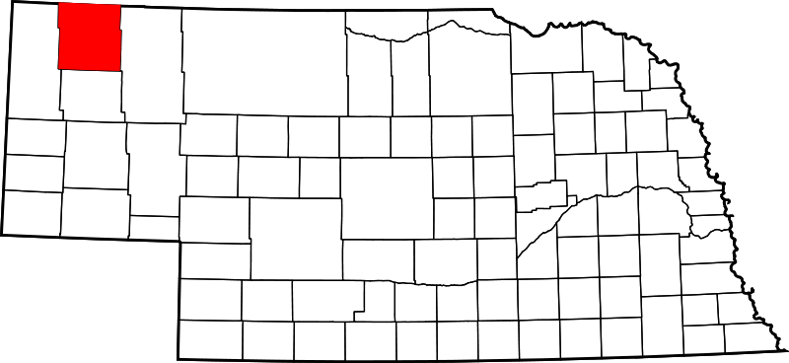

2016 Dawes County Youth (Ages 10-17)
Data was collected from the Office of Juvenile Delinquency’s Easy Access to Juvenile Populations (http://ojjdp.gov/ojstatbb/ezapop/asp/profile_selection.asp)
Race/Ethnicity | Number | Percent
White | 598 | 81.1%
Black | 24 | 3.3%
American Indian | 37 | 5.0%
Asian | 10 | 1.4%
Hispanic* | 68 | 9.2%
Total | 737 | 100.0%

*May include another racial group

CY 2016: (Under 17) Juvenile Arrests http://www.nebraska.gov/crime_commission/arrest/arrest.cgi
Department Name | Number | Percent
Nebraska State Patrol | 12 | 31.6%
Chadron Police Department | 21 | 55.3%
Dawes Co. Sheriff’s Office | 5 | 13.1%
Total | 38 | 100.0%

CY 2016: (Under 17) Juvenile Arrests by Race/Ethnicity
http://www.nebraska.gov/crime_commission/arrest/arrest.cgi
Race/Ethnicity | Number | Percent
White | 34 | 89.5%
Black | 0 | 0.0%
Native American | 4 | 10.5%
Asian | 0 | 0.0%
Unknown | 0 | 0.0%
Total | 38 | 100.0%

Court Filings: Juvenile FY 2016/17 & Adult CY 2015
Juvenile court data collected from The Nebraska Supreme Court Administrative Office of Courts/Probation: County Court Annual Caseload Report; https://supremecourt.nebraska.gov/sites/default/files/FY-2017-county-caseload-report.pdf
Adult court data collected by Kids Count/Voices for Children in Nebraska; http://voicesforchildren.com/wp-content/uploads/2017/01/2016-Kids-Count.pdf
Court | Number
Juvenile Court | 51
Adult Court (Source: JUSTICE, Administrative Office of the Courts) | 20

CY 2016: Child Welfare Indicators (Ages 0-17)
Data was collected by Kids Count/Voices for Children in Nebraska
Child Welfare Indicators | Number | Percent
Percent of Children in Poverty  (Source: US Census Bureau, 2010-2014 American Community Survey 5-year Averages Table B17001) | 281 | 17.7%
Number of Children experienced Substantiated Maltreatment (Source: Nebraska Department of Health and Human Services CY2015) | 7 | 0.4%
Number of children in out of home care (Source: Nebraska Department of Health and Human Services CY2015) | 5 | 0.3%
Number of high school graduates | Data not Available | Data not Available

*Numbers are based on 1,588 total children ages 0-17

CY 2016: Referrals to Juvenile Diversion
Data was collected from the Nebraska Juvenile Diversion Case Management System through the Nebraska Commission on Law Enforcement and Criminal Justice.
Race/Ethnicity | Number | Percent
Total Referred to Diversion |  | %

CY 2016: Youth Enrolled in Juvenile Diversion
Data was collected from the Nebraska Juvenile Diversion Case Management System through the Nebraska Commission on Law Enforcement and Criminal Justice
Race/Ethnicity | Number | Percent
Total Enrolled |  | %

CY 2016: Reasons for Non-Enrollment
Data was collected from the Nebraska Juvenile Diversion Case Management System through the Nebraska Commission on Law Enforcement and Criminal Justice

Closure Reason | Number | Percent
Total Closures |  | %

Note: The above numbers represent youth with no diversion enrollment date, i.e., youth who did not officially enroll in a diversion program.

CY 2016: Outcomes for Juvenile Diversion
Data was collected from the Nebraska Juvenile Diversion Case Management System through the Nebraska Commission on Law Enforcement and Criminal Justice
Discharge Reason | Number | Percent | Statewide
County/City Attorney or school withdrew youth's referral to diversion program | - | - | %
Diversion program declined admission | - | - | %
Juvenile discharged from diversion, no further legal action | - | - | %
Juvenile failed to comply with program conditions | - | - | %
Juvenile had new law violation(s) | - | - | %
Other (moved away, death, etc.) | - | - | %
Youth/Parent refused diversion | - | - | %
Unspecified/Unknown | - | - | %
Total | - | - | %

Note: The above numbers represent youth with an assigned diversion enrollment date, i.e., youth who officially enrolled in a diversion program.

CY 2016: Youth on Probation in Dawes County
Data was collected from the Nebraska Probation Administration
https://supremecourt.nebraska.gov/sites/default/files/2016-juvenile-justice-system-statistical-annual-report-viewing.pdf
Race/Ethnicity | Number | Percent
White | 24 | 80.0%
Black | 0 | 0.0%
American Indian | 2 | 6.7%
Unknown | 2 | 6.7%
*Hispanic | 2 | 6.7%
Total Youth Placed on Probation | 30 | 100.0%

*May include another racial group

FY 2016: Youth in Geneva and Kearney
Data was collected from the YRTC Annual Reports located online at http://dhhs.ne.gov/Reports/Youth%20Rehabilitation%20and%20Treatment%20Center%20Geneva%20Annual%20Report%20-%202016-2017.pdf
http://dhhs.ne.gov/Reports/Youth%20Rehabilitation%20and%20Treatment%20Center%20Kearney%20Annual%20Report%20-%202016-2017.pdf
 | Number
YRTC Geneva | 0
YRTC Kearney | 0
Total | 0

Note: The tables in this document include duplicate counts.

This report provides only a snapshot of the county’s juvenile justice system. Further research should include success rates by intervention and a determination of which programs are effective, promising or evidence based.

If you have questions or comments, contact Dr. Anne Hobbs at ahobbs2@unl.edu.

