Sheridan County Juvenile Justice Data – 2016/17
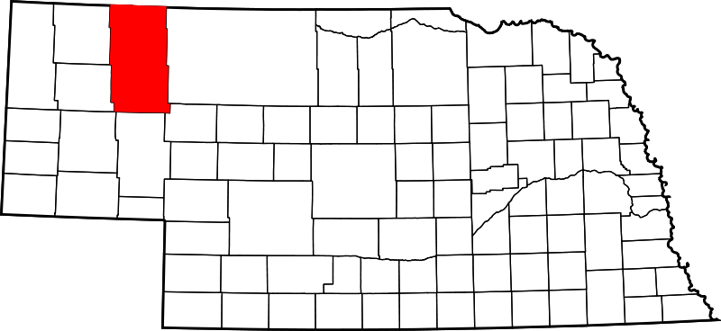

2016 Sheridan County Youth (Ages 10-17)
Data was collected from the Office of Juvenile Delinquency’s Easy Access to Juvenile Populations (http://ojjdp.gov/ojstatbb/ezapop/asp/profile_selection.asp)
Race/Ethnicity | Number | Percent
White | 407 | 72.5%
Black | 9 | 1.6%
American Indian | 99 | 17.6%
Asian | 4 | 0.7%
Hispanic* | 42 | 7.5%
Total | 561 | 100.0%

*May include another racial group

CY 2016: (Under 17) Juvenile Arrests http://www.nebraska.gov/crime_commission/arrest/arrest.cgi
Department Name | Number | Percent
Nebraska State Patrol | 1 | 33.3%
Gordon Police Department | 0 | 0.0%
Sheridan Co. Sheriff’s Office | 2 | 66.7%
Total | 3 | 100.0%

CY 2016: (Under 17) Juvenile Arrests by Race/Ethnicity
http://www.nebraska.gov/crime_commission/arrest/arrest.cgi
Race/Ethnicity | Number | Percent
White | 1 | 33.3%
Black | 0 | 0.0%
Native American | 2 | 66.7%
Asian | 0 | 0.0%
Total | 3 | 100.0%

Court Filings: Juvenile FY 2016/17 & Adult CY 2015
Juvenile court data collected from The Nebraska Supreme Court Administrative Office of Courts/Probation: County Court Annual Caseload Report; https://supremecourt.nebraska.gov/sites/default/files/FY-2017-county-caseload-report.pdf
Adult court data collected by Kids Count/Voices for Children in Nebraska; http://voicesforchildren.com/wp-content/uploads/2017/01/2016-Kids-Count.pdf
Court | Number
Juvenile Court | 45
Adult Court (Source: JUSTICE, Administrative Office of the Courts) | 32

CY 2016: Child Welfare Indicators (Ages 0-17)
Data was collected by Kids Count/Voices for Children in Nebraska
Child Welfare Indicators | Number | Percent
Percent of Children in Poverty  (Source: US Census Bureau, 2010-2014 American Community Survey 5-year Averages Table B01001) | 407 | 23.3%
Number of Children experienced Substantiated Maltreatment (Source: Nebraska Department of Health and Human Services CY 2015) | 8 | 0.5%
Number of children in out of home care (Source: Nebraska Department of Health and Human Services CY 2015) | 14 | 0.8%
Number of high school graduates | Data not Available | Data not Available

*Numbers are based on 1,747 total children ages 0-17

CY 2016: Referrals to Juvenile Diversion
Data was collected from the Nebraska Juvenile Diversion Case Management System through the Nebraska Commission on Law Enforcement and Criminal Justice.
 | Number | Percent
Total Referred to Diversion |  | %

CY 2016: Youth Enrolled in Juvenile Diversion
Data was collected from the Nebraska Juvenile Diversion Case Management System through the Nebraska Commission on Law Enforcement and Criminal Justice
 | Number | Percent
Total Enrolled |  | %

CY 2016: Reasons for Non-Enrollment
Data was collected from the Nebraska Juvenile Diversion Case Management System through the Nebraska Commission on Law Enforcement and Criminal Justice

Closure Reason | Number | Percent
Total Closures |  | %

Note: The above numbers represent youth with no diversion enrollment date, i.e., youth who did not officially enroll in a diversion program.

CY 2016: Outcomes for Juvenile Diversion
Data was collected from the Nebraska Juvenile Diversion Case Management System through the Nebraska Commission on Law Enforcement and Criminal Justice
Discharge Reason | Number | Percent | Statewide
County/City Attorney or school withdrew youth's referral to diversion program |  | % | %
Diversion program declined admission |  | % | %
Juvenile discharged from diversion, no further legal action |  | % | %
Juvenile failed to comply with program conditions |  | % | %
Juvenile had new law violation(s) |  | % | %
Other (moved away, death, etc.) |  | % | %
Youth/Parent refused diversion |  | % | %
Unspecified/Unknown |  | % | %
Total |  | % | %

Note: The above numbers represent youth with an assigned diversion enrollment date, i.e., youth who officially enrolled in a diversion program.

CY 2016: Youth on Probation in Platte County
Data was collected from the Nebraska Probation Administration
https://supremecourt.nebraska.gov/sites/default/files/2016-juvenile-justice-system-statistical-annual-report-viewing.pdf
Race/Ethnicity | Number | Percent
White | 5 | 20.0%
Black | 0 | 0.0%
American Indian | 20 | 80.0%
Asian | 0 | 0.0%
Hispanic* | 0 | 0.0%
Total Youth Placed on Probation | 25 | 100.0%

*May include another racial group

FY 2016: Youth in Geneva and Kearney
Data was collected from the YRTC Annual Reports located online at http://dhhs.ne.gov/Reports/Youth%20Rehabilitation%20and%20Treatment%20Center%20Geneva%20Annual%20Report%20-%202016-2017.pdf
http://dhhs.ne.gov/Reports/Youth%20Rehabilitation%20and%20Treatment%20Center%20Kearney%20Annual%20Report%20-%202016-2017.pdf
 | Number
YRTC Geneva | 0
YRTC Kearney | 0
Total | 0

Note: The tables in this document include duplicate counts.

This report provides only a snapshot of the county’s juvenile justice system. Further research should include success rates by intervention and a determination of which programs are effective, promising or evidence based.

If you have questions or comments, contact Dr. Anne Hobbs at ahobbs2@unl.edu.

